Crate Diggers Paradise
Official User Instructional Manual
Version 1.0

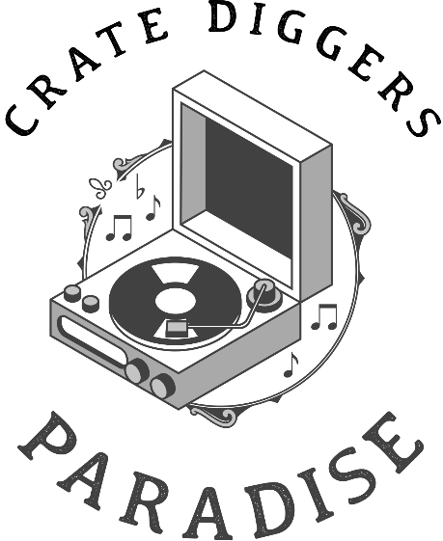
Sample Anything. Release Everything. Create Without Limits

Table of Contents
- Introduction to Crate Diggers Paradise
- Creating an Account and Getting Started
- Understanding Licensing on Crate Diggers Paradise
- Searching for Music and Samples
- Using the Crate Diggers Paradise Player and Tools
- Downloading and Using Music in Your Projects
- Clearing Samples and Releasing Music
- Best Practices and Common Mistakes to Avoid
- Frequently Asked Questions (FAQ)
- Conclusion

1. Introduction to Crate Diggers Paradise
Crate Diggers Paradise is a creator-first music sampling platform built for producers who value authenticity, culture, and creative freedom—without the legal gray area. Our mission is simple: give artists access to real music, real records, and real inspiration, while keeping the business side clear, fair, and transparent.
Unlike traditional sample libraries that rely on pre-packaged sounds, Crate Diggers Paradise is designed around the art of digging. You explore full-length tracks, uncover hidden moments, and flip them into something new—just like crate digging in the physical world, but built for the modern producer.
This manual serves as an official guide to using Crate Diggers Paradise from sign-up to release. It explains how to navigate the platform, understand our licensing philosophy, and move confidently from idea to distribution.

2. Creating an Account and Getting Started

Step 1: Sign Up
To begin using Crate Diggers Paradise, visit the Crate Diggers Paradise website and select the option to create an account. Users may sign up using an email address or supported third-party login methods. During registration, you will be asked to provide basic information such as your name, email address, and password.

Step 2: Choose a Subscription Plan
Crate Diggers Paradise operates on a subscription-based model. After creating an account, you will be prompted to choose a subscription plan. Plans vary based on the number of downloads per month and the audio quality available. Select a plan that aligns with your production needs and budget.

Step 3: Account Dashboard Overview
Once logged in, you will be directed to your dashboard. This area provides access to your account settings, download history, saved tracks, and licensing information. Familiarizing yourself with the dashboard will make navigation more efficient as you begin exploring the platform.

3. Understanding Licensing on Crate Diggers Paradise
Crate Diggers Paradise was built to remove confusion around sampling rights. Our licensing model is designed to be creator‑friendly, scalable, and transparent—so you can focus on making music, not chasing paperwork.

Our Licensing Philosophy
- Clear from the start: Every track includes upfront usage terms
- Built to scale: Licenses grow with your success
- Artist‑respecting: Original creators are compensated fairly

Pricing & License Tiers
Crate Diggers Paradise uses a tiered model inspired by real-world release paths. Artists can start small and scale up only when success demands it.
Basement Tier – $15 per month
Designed for hobbyists and independent creators releasing music non‑commercially or at a very small scale. Ideal for demos, beat tapes, and early SoundCloud or Bandcamp uploads.
Indie Tier – $75 per month
Built for serious independent artists distributing music on streaming platforms. Covers moderate revenue generation and small label releases.
Label Tier – $300 per month
Intended for high‑visibility releases, major distribution, sync placements, and label‑backed projects. Includes full commercial clearance and expanded usage rights.
Licenses may be upgraded at any time if a release exceeds its original scope.

5. Using the Crate Diggers Paradise Player and Tools
Crate Diggers Paradise includes an integrated audio player that allows users to listen to tracks directly on the site.

6. Downloading and Using Music in Your Projects

Downloading Audio
Once you’ve identified a track, downloads are available in high-quality audio formats suitable for professional production. Each download is linked to your account, creating a clear record of usage.

Creative Use in Your Workflow
Crate Diggers Paradise places no creative limits on how you manipulate a sample. You are free to chop, stretch, pitch, reverse, and transform the audio within your DAW. The goal is creative reinterpretation—not restriction.

Staying Organized
We recommend keeping project notes that include the original track name, artist, and cleared license tier. While your account stores this information, personal documentation helps streamline future releases and collaborations.

7. Clearing Samples and Releasing Music
Before releasing music that includes Crate Diggers Paradise samples, you must ensure the sample is properly cleared.

Clearing a Sample
- Log into your Crate Diggers Paradise account
- Navigate to the track you used
- Select the option to clear the sample
- Confirm the licensing tier based on your projected revenue
Once cleared, you are legally permitted to distribute your music on streaming platforms, sell it commercially, or use it in other monetized content.

8. Best Practices and Common Mistakes to Avoid

Best Practices
- Always review licensing terms before downloading
- Clear samples before releasing music
- Use favorites and playlists to stay organized

Common Mistakes
- Assuming all samples are free to use without clearance
- Ignoring revenue thresholds in licensing tiers
- Failing to keep track of which samples were used in a project
Avoiding these mistakes will save time and prevent legal complications.

9. Frequently Asked Questions (FAQ)
Q: Can I use Crate Diggers Paradise samples for commercial projects?
Yes, as long as the sample is properly licensed and cleared.
Q: Do I need to credit the original artist?
Attribution requirements depend on the specific license terms provided.
Q: What happens if my song becomes more successful than expected?
You may need to upgrade your license tier to match the new revenue level.

10. Conclusion
Crate Diggers Paradise exists to support the culture of sampling while protecting the artists who make it possible. By combining intuitive tools, transparent licensing, and a creator-first mindset, the platform empowers producers to dig freely and release confidently.
Whether you are an independent beatmaker or a professional artist preparing a commercial release, following the practices outlined in this manual will ensure your creative work remains both inspired and protected.

Appendix A: Glossary of Terms
DAW (Digital Audio Workstation): Software used to create and edit music (e.g., Ableton Live, FL Studio).
Sample Clearance: The legal permission required to use a portion of an existing recording.
License Tier: A pricing level that corresponds to how a sampled track is released and monetized.

Appendix B: Release Checklist
- Sample selected from Crate Diggers Paradise
- License terms reviewed
- Sample cleared under correct tier
- Documentation saved
- Track released on distribution platforms

